

 





**“Cust-IT!!” – One Stop Destination for Customized Clothing and Apparels Team Introduction:**

|  |  |
| --- | --- |
| **Data Diva (Data Designer)**  **Venkat** | Hi, this is Venkat! In the realm of data, SQL is my wand, and the database is my canvas. With a flick of my queries, I orchestrate data in a way that transforms chaos into a melodious dance. Just as a composer crafts music, I compose the data into elegant symphonies that reveal the stories hidden within and tries to turn the complex queries into harmonious symphonies! |
| **Data Dynamo (Data Analyst)**  **Pavan** | Hi, this is Pavan! Just as Sherlock Holmes dissects clues and solves mysteries, I delve into the depths of data. I am the investigator who scours the digital landscape, revealing secrets and unravelling the stories that data conceals. With data as magnifying glass and algorithms as my trusty sidekick, I am here to unlock the truth and shed light on the most cryptic of data puzzles. |
| **Schema Sorcerer (Schema Specialist)**  **Kartheek** | Hi, this is Kartheek! Just as a master architect designs the blueprint for a magnificent structure, I craft the foundation of our digital world. I meticulously design the schema, ensuring that our data structures are not robust but elegant, ready to support the weight of our ambitions by building the Digital Realm’s Foundation with Precision. |
| **Query Queen (Query Optimization Expert)**  **Rupa** | Hi, this is Rupa! In the world of data, efficiency is the name of the game. I orchestrate our database to achieve peak performance. I craft queries in a better way ensuring that even when faced with colossal data volumes, our systems hums with grace and agility. |
| **Data Artisan**  **(Data Visualization Expert)**  **Dinesh** | Hi, this is Dinesh! Just as Artist wields a brush to create stunning canvases, I harness the power of visualization to turn raw data into captivating narratives. Each chart and graph I design is a stroke of insight, transforming complex information into a symphony of colors and shapes that not only inform but also inspire. I bring life to the data, and in doing so, I make it accessible and unforgettable. |

Together, we are the DBMS- “In Keaton, We Trust! “Team, and our mission is to conquer the data labyrinth and transform it into a treasure trove of insights for our project. We will try to build a unique business model and inspire others by doing so…

**Scope of the Project:**

The scope of a customized e-commerce business model like us can be quite significant and promising. It also caters to the increasing demand for the personalized fashion and will value every individual expression regarding the fashion and design. Trying to build a loyal customer base in the Niche markets eco-friendly clothing, athletic wear, cultural apparel. This Business model can also overcome the scalability issues, risk of over-customization and over-production thus building the successful business with huge profits.

# Drawbacks in the Current Customized E-Commerce Business Model:

While customized e-commerce business models offer several advantages, they also come along with their set of drawbacks and challenges. This includes:

1. Limited Scalability
2. Not giving the importance to the customers interest in the clothing they wear
3. Not unleashing the design skills in the customers
4. Risk of Over-customization
5. Risk of Over-production

**Description of Intended Solution:**

Here, we are trying to sell the Clothes, Apparels, and other gifts in a customized fashion desired by the users. Here customers will have the authority to choose their color, size, style, fabric type, text to be printed on it, any graphic elements to be printed on it (here they can choose the graphics from a wide range of styles we have and can upload the one they adore).

Here, unlike other business models, we are trying to focus on the Supply on Demand Production strategies by running different campaigns like Polling the customized clothes and gifts, suggesting new customization trends, targeting the diverse customer base by running a different social media campaigns. For Example: We will run Color of the month, Design of the Month like campaigns to produce the desired color and design for that month and solving the problem of overproduction.

Here Unlike the Walmart and Amazon having high scalability, our business model will have the less Scalability at the initial stage, and we can have a good customer support too.

Thus, Trying to Build More HAPPY CUSTOMERS!! Through Our Model.



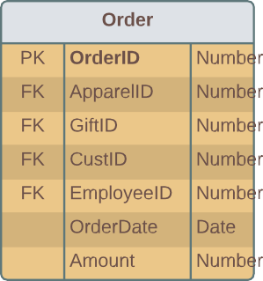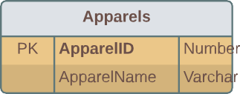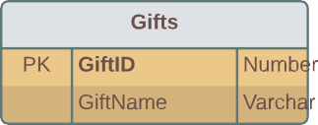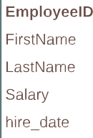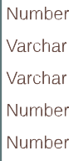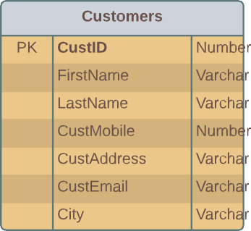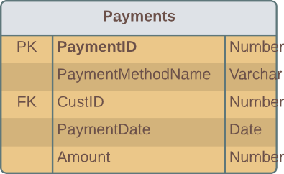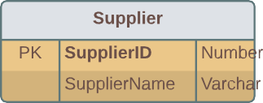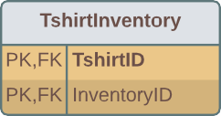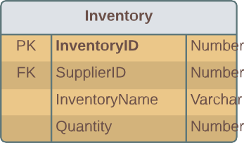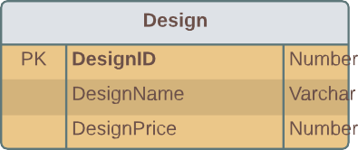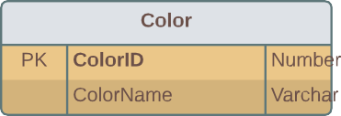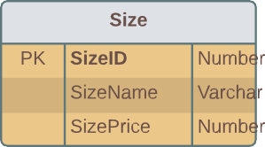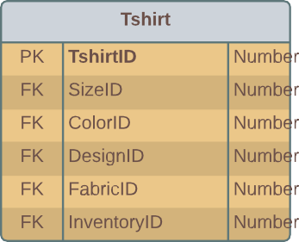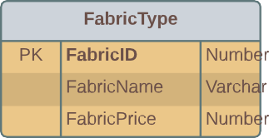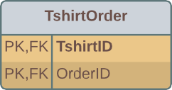



# BUSINESS RULES



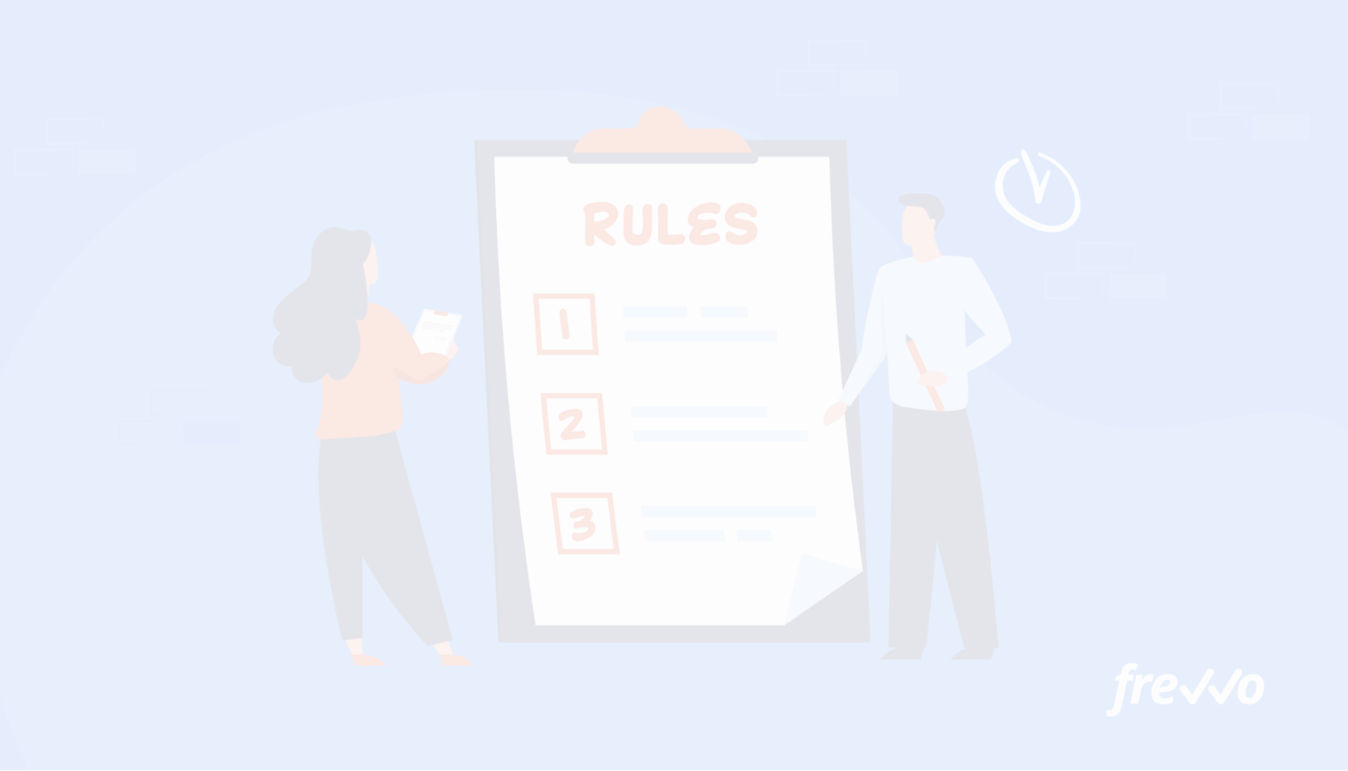While implementing customized e-commerce business model, it is important to establish specific business rules to govern data management, access and security.

Here are some BUSINESS RULES for Customized E-commerce Business Model:

1. Validate the orders and prevent duplicate or fraudulent orders.
2. Securely handle payment data and transactions following proper standards.
3. Restrict the access to customer payment information to authorized person only.
4. Track and update the inventory levels in real-time to prevent overselling and stacking.
5. Protect the customers data by strictly following the data regulations.
6. Try to manage the marketing campaigns and track their awareness in real-time thereby increase your business.
7. Apply the pricing rules continuously and consistently, calculate the discounts accurately based on the seasonal discounts on your desired data ranges.
8. Gather all the feedback from the Customers so that it will be helpful in improving the E- Commerce business platform.

These business rules will serve as a foundation for our Customized E-Commerce business model and help us to ensure that our operations will run smoothly and customer-friendly by following the relevant rules and regulations. Moreover, these rules can be integrated with our application’s logic and user interfaces to provide an easy and efficient E-commerce experience to the customers.





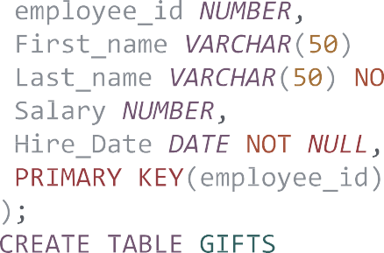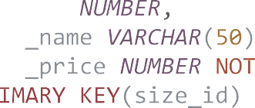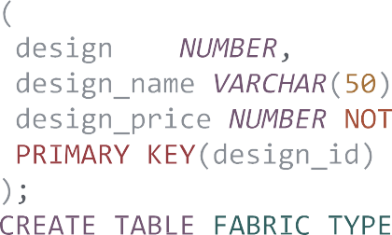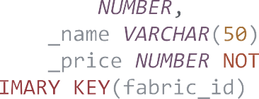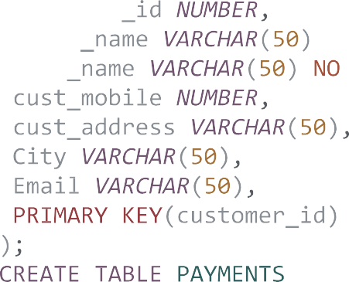



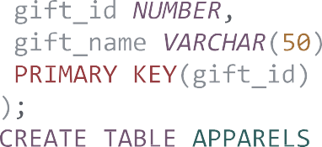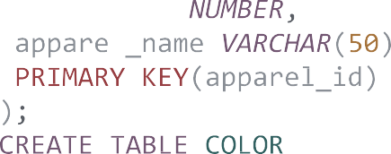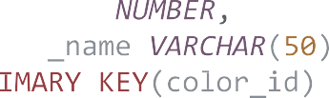



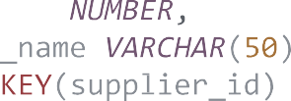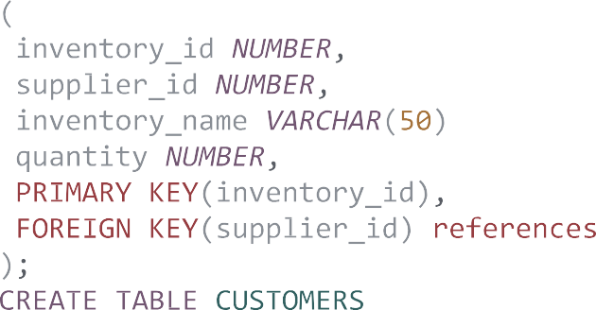



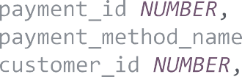

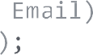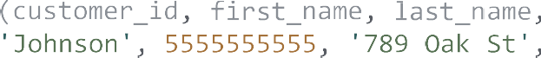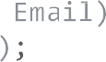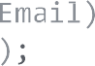

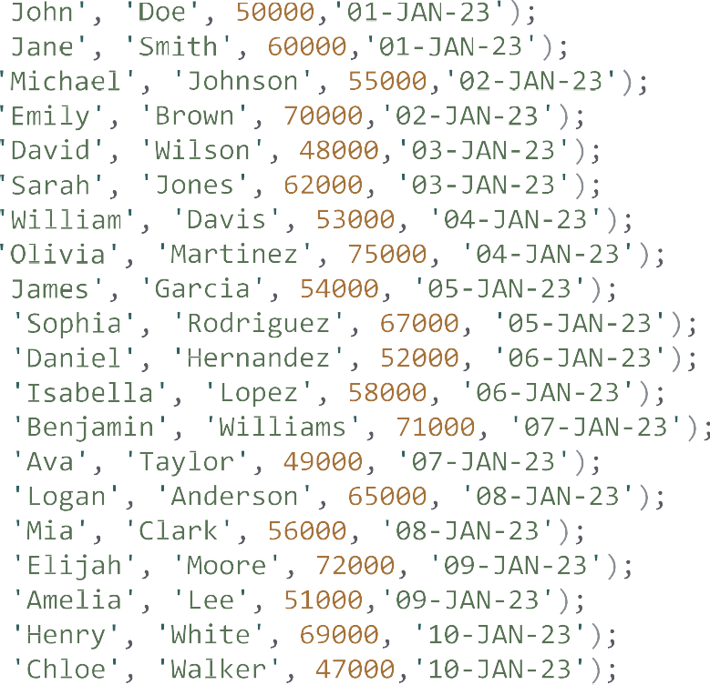



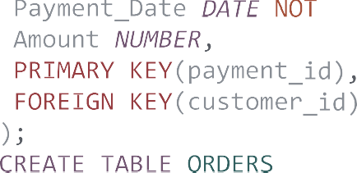

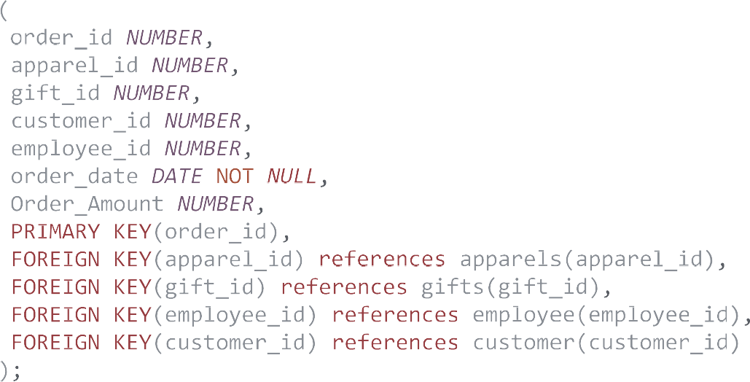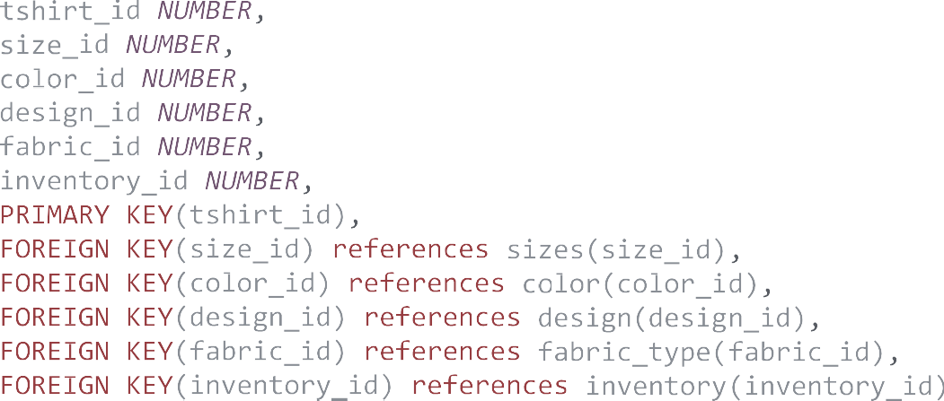









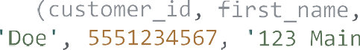





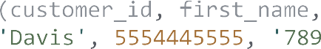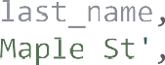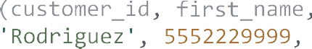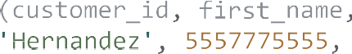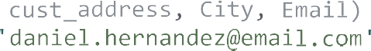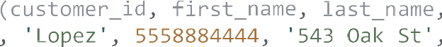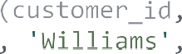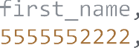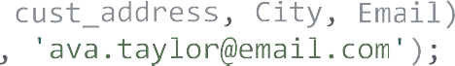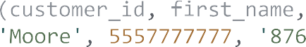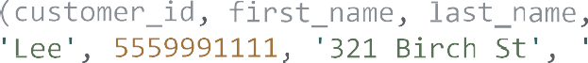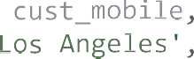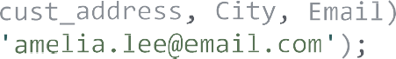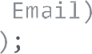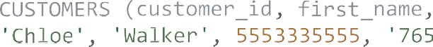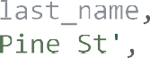       

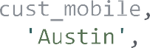























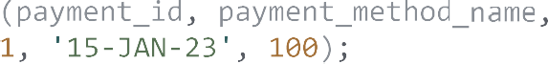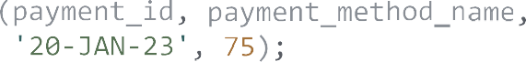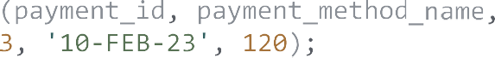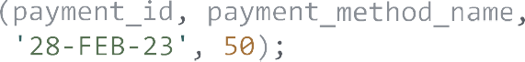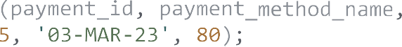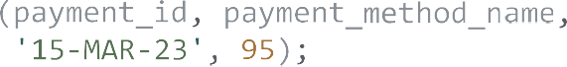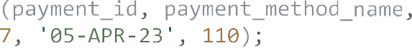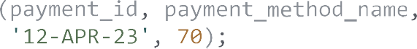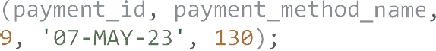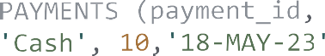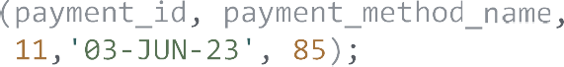

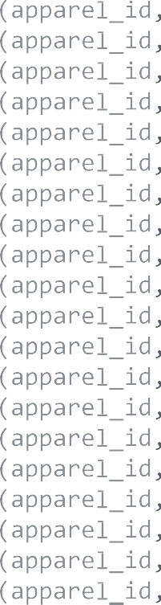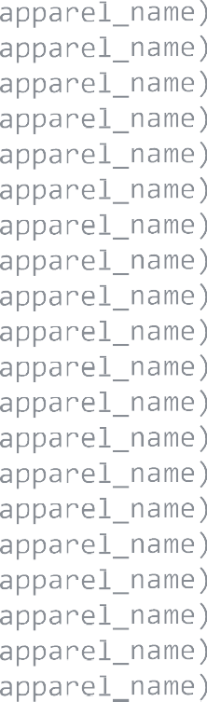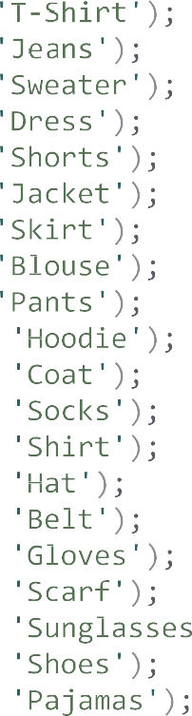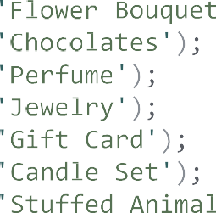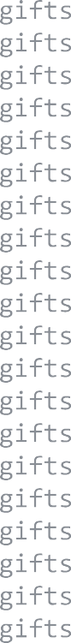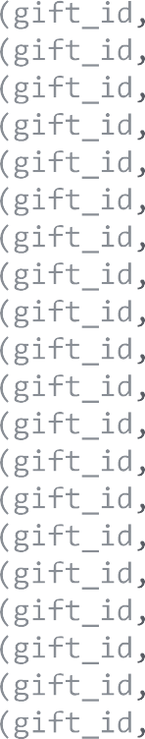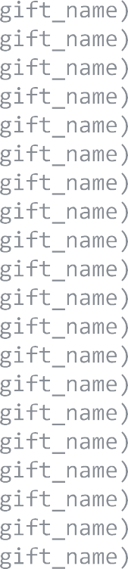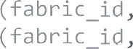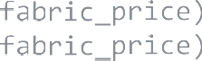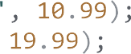

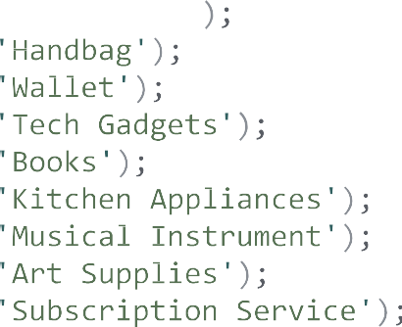

     

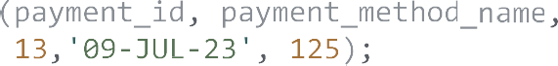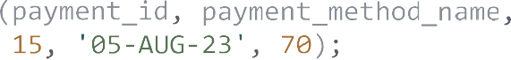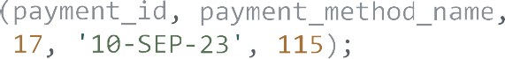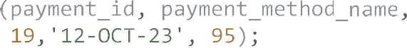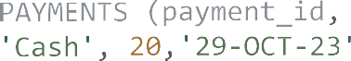



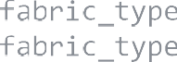

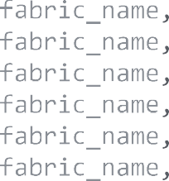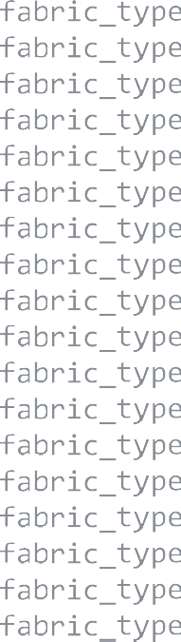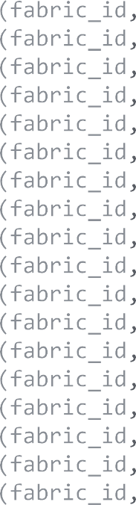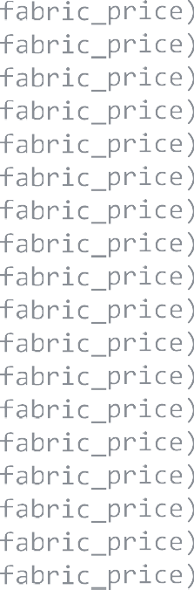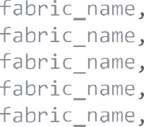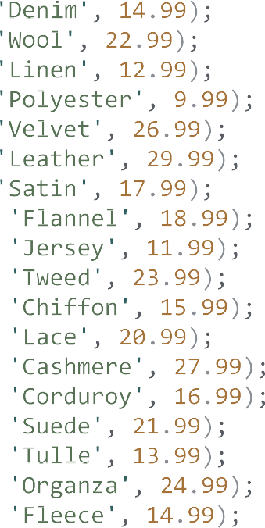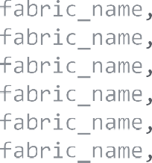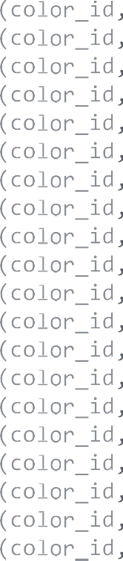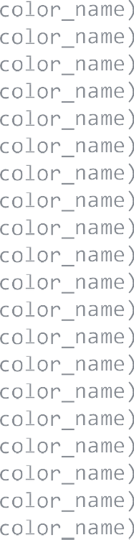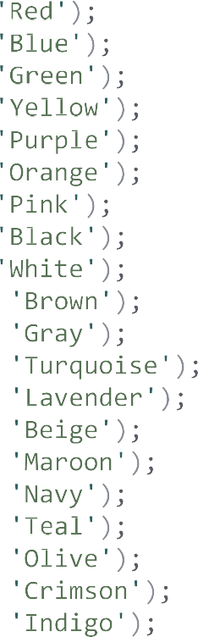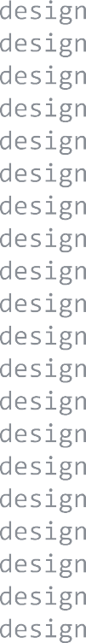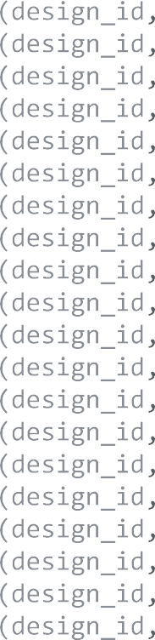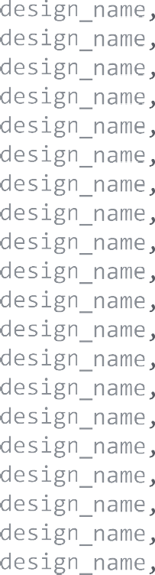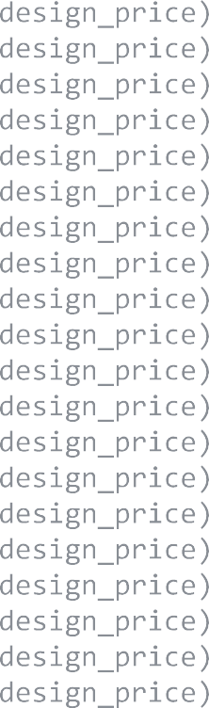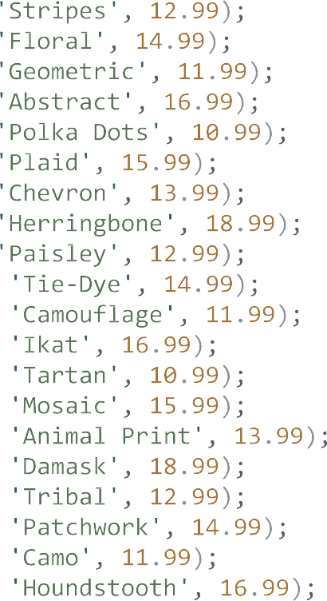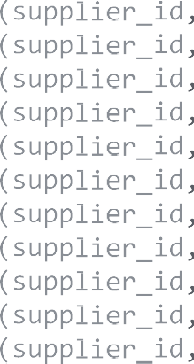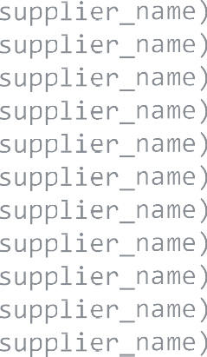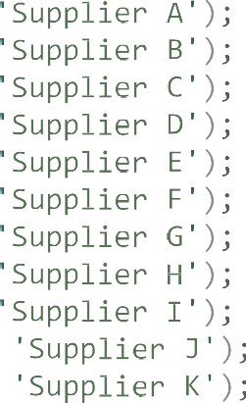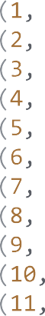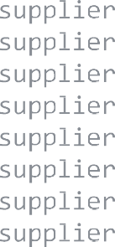

  









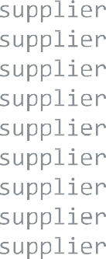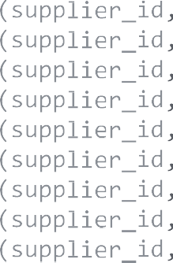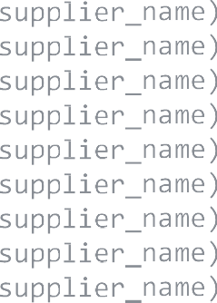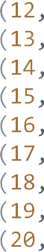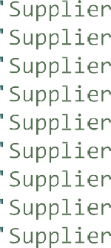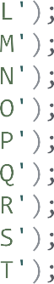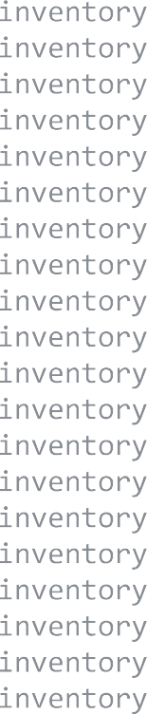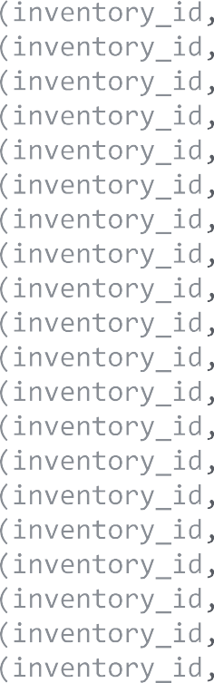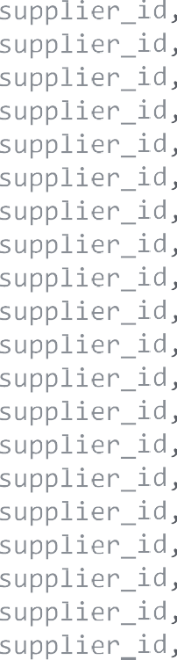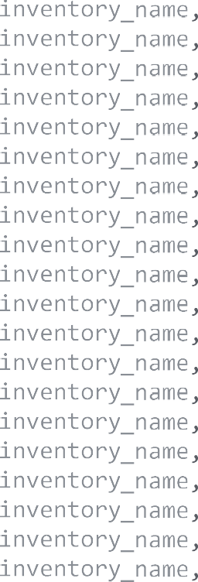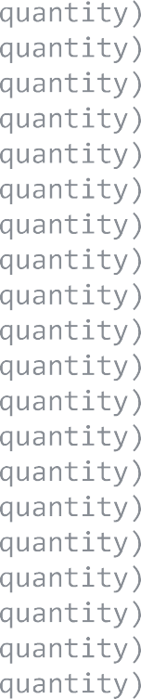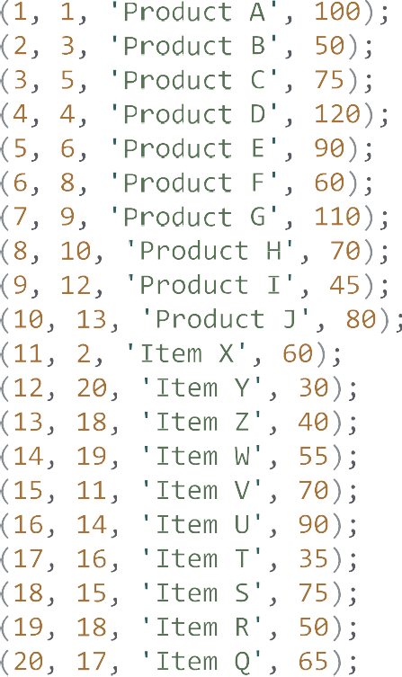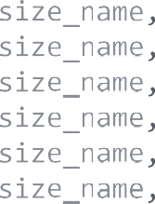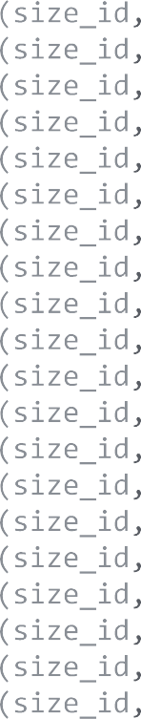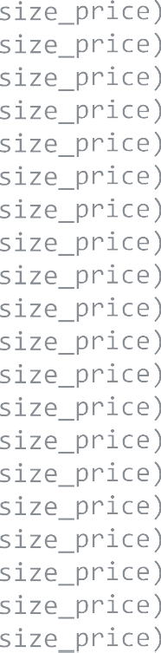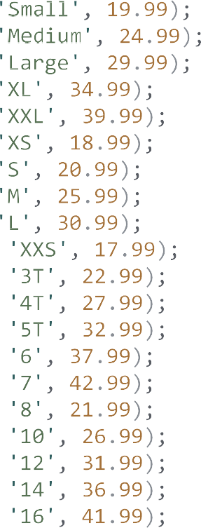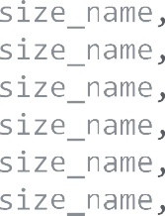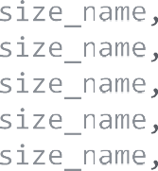

  







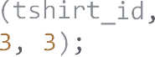

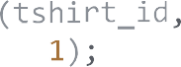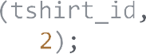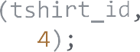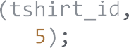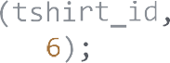

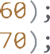      

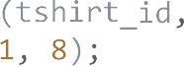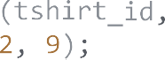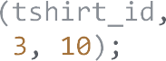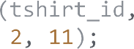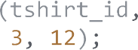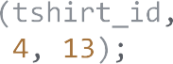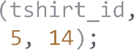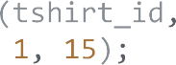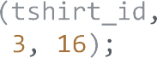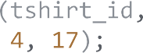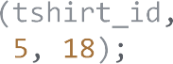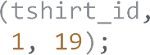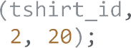











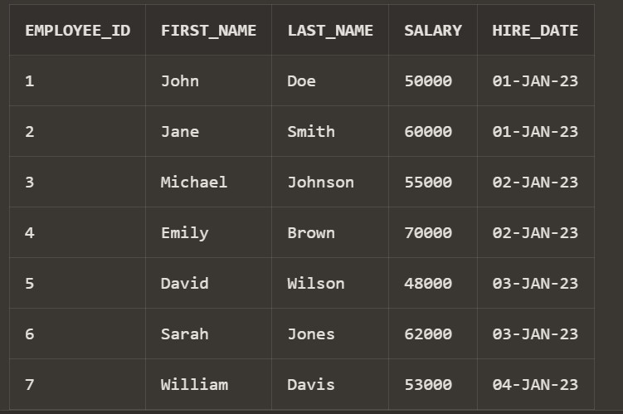

Gifts table:

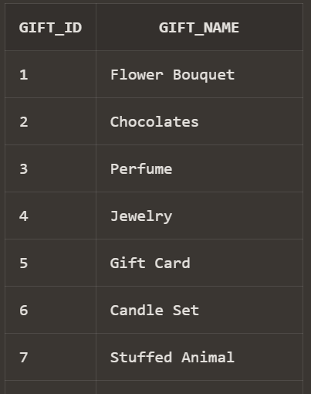

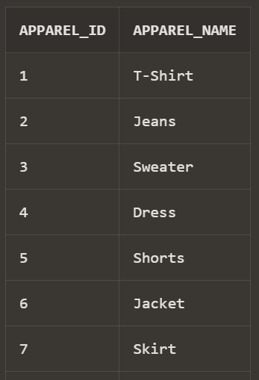

Color table:

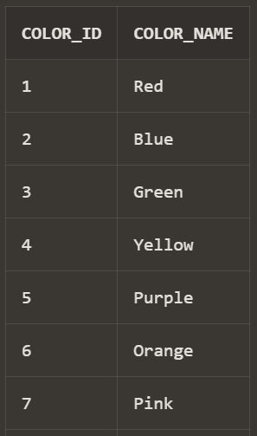

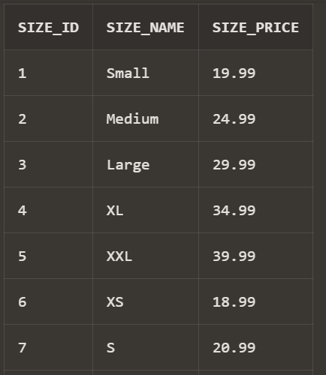

Design table:

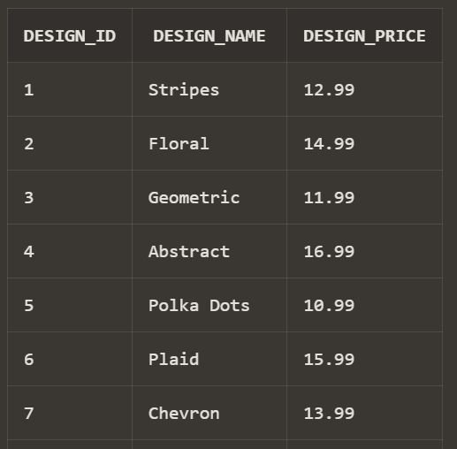

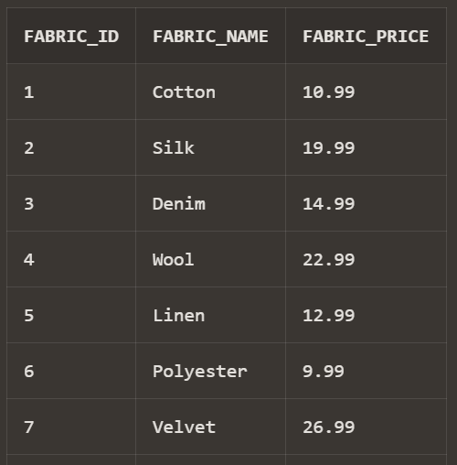

Supplier table :

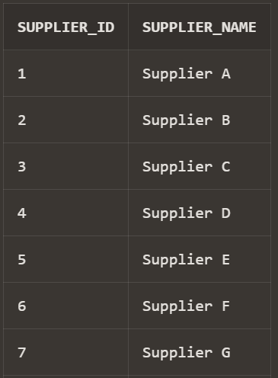

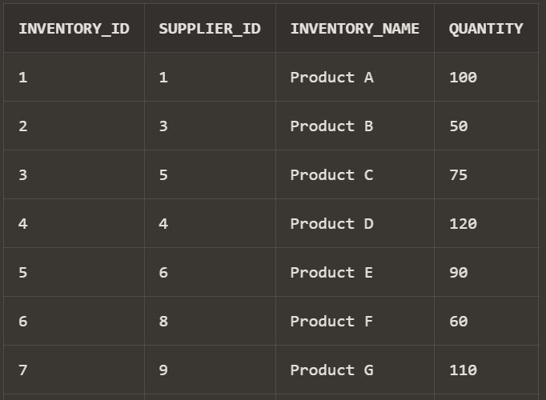

Customers table:

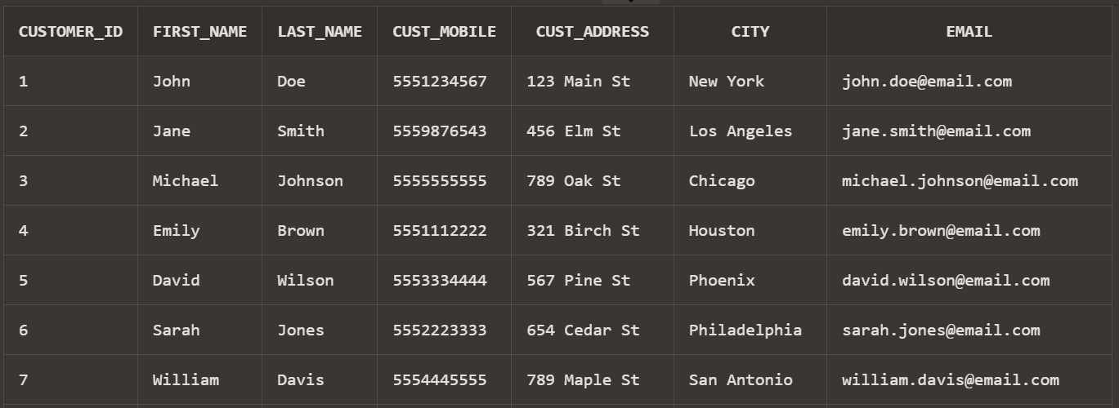

Payments table:

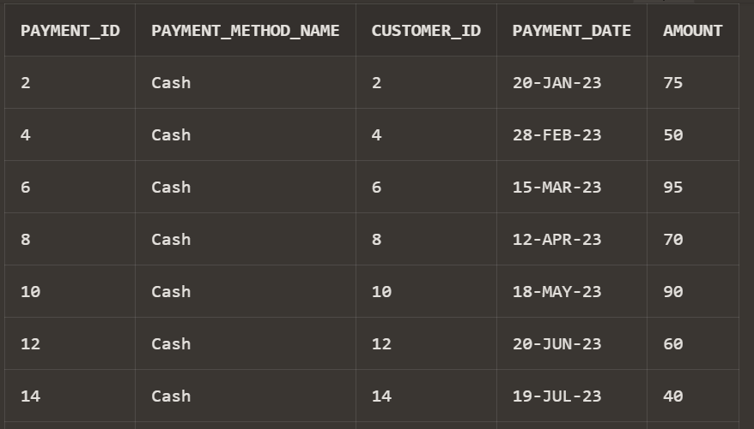

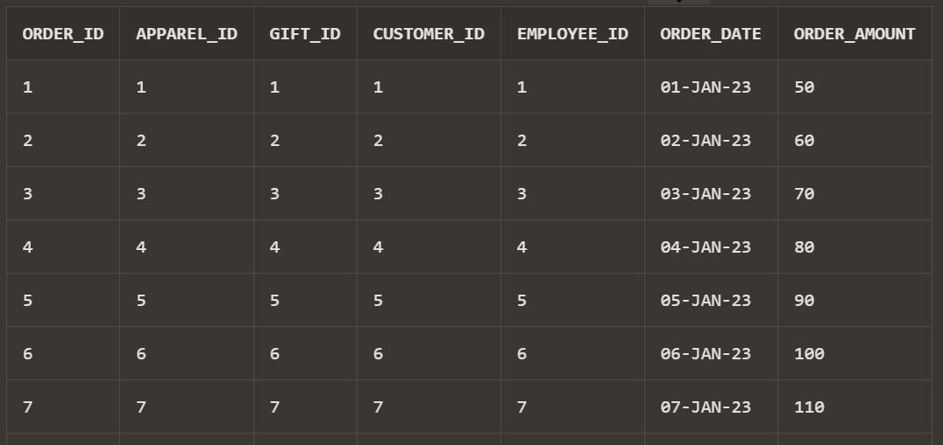

Tshirts table:

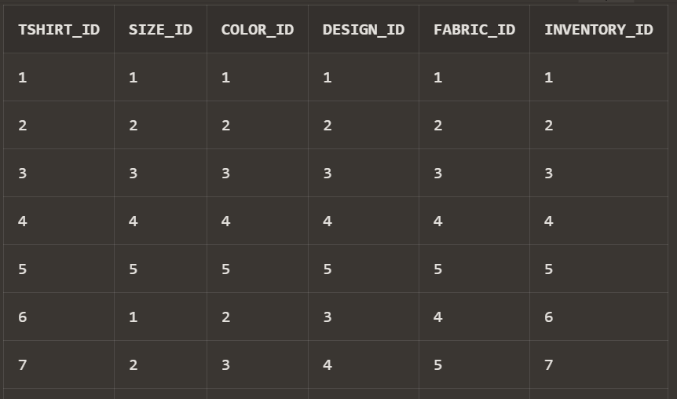



Group Project 4 : Queries using more than 15 different concepts…. For our Project Schema

Query 1 :

Selecting the employee id with avg salaries > 60000……

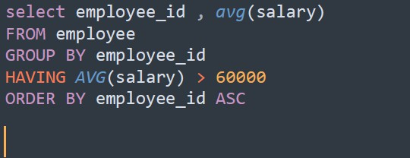

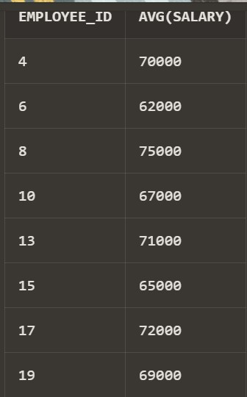

Query 2 :

Selecting the employee_id with the number greater than 10, and using some Single row functions and aggregate functions…



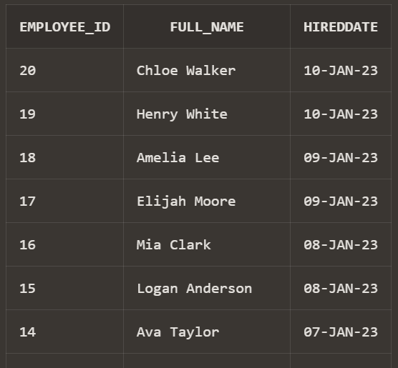

Query 3 :

Selecting customers with the ID between 5 and 15 or with Customer city as Austin along with using some JOIN functions and some comparison and logical operators…

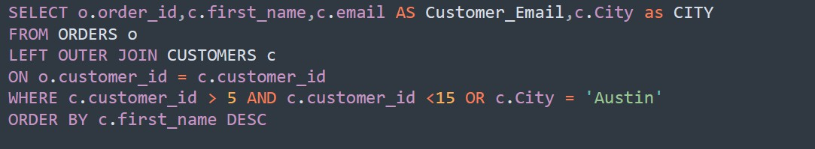

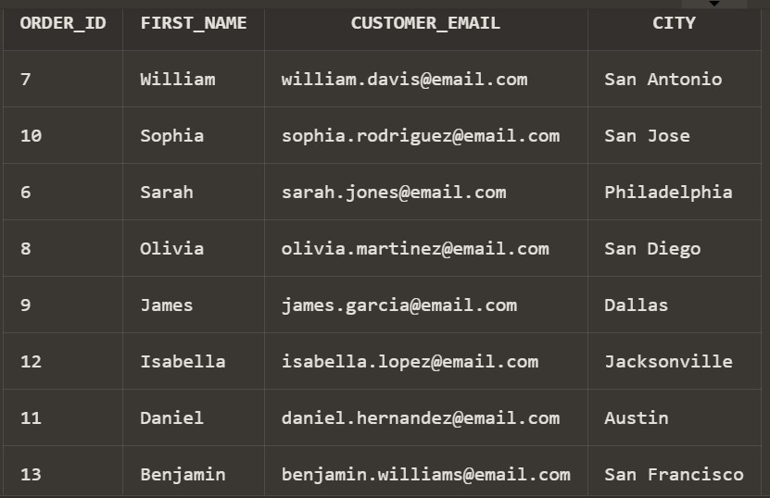

Query 4 :

Selecting the firstname and the count of the customers with the same payment_id and customer_id

along with the City of the Customer not equal to the ‘Austin’ along with using some crazy subqueries in all the SELECT, FROM and WHERE clause of the query.

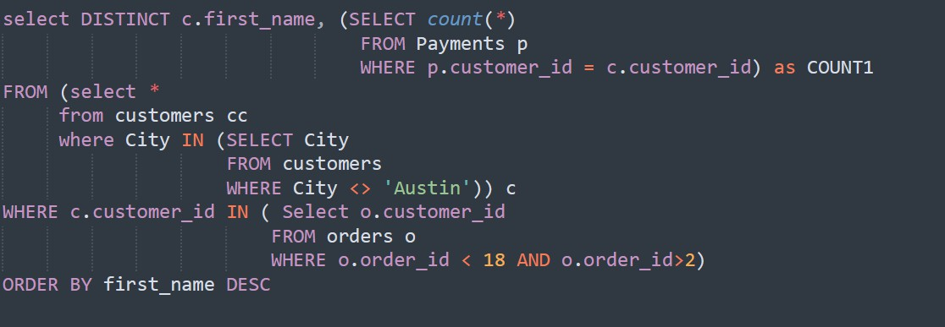

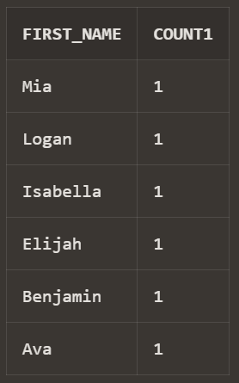

Query 5:

Selecting the customer ID with the City of his/her as ‘New York’ along with using some single row functions .

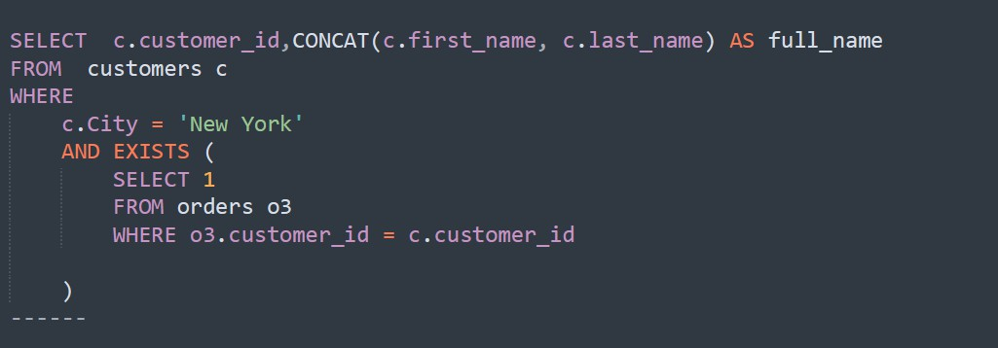

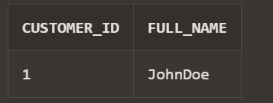

Group Project – 5 (Data Visualizations)

In KEATON, We TRUST!!

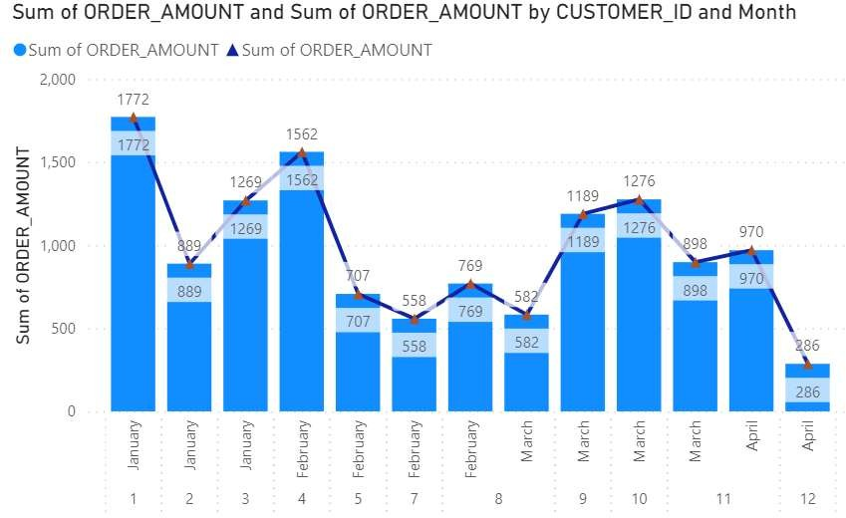 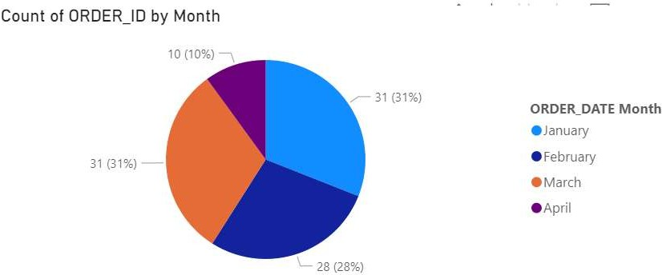

Sum of Order Amount (MONTH-WISE) Total Percentage of Orders Made

(MONTH-WISE)

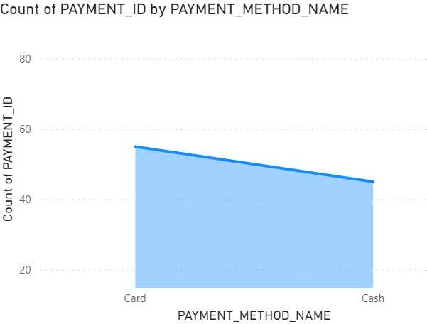 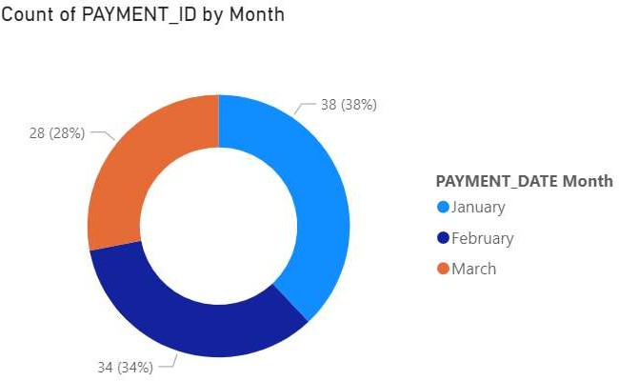

Sum of Payments Done (METHOD-WISE) Total Percentage of Payments-Made

(MONTH-WISE)

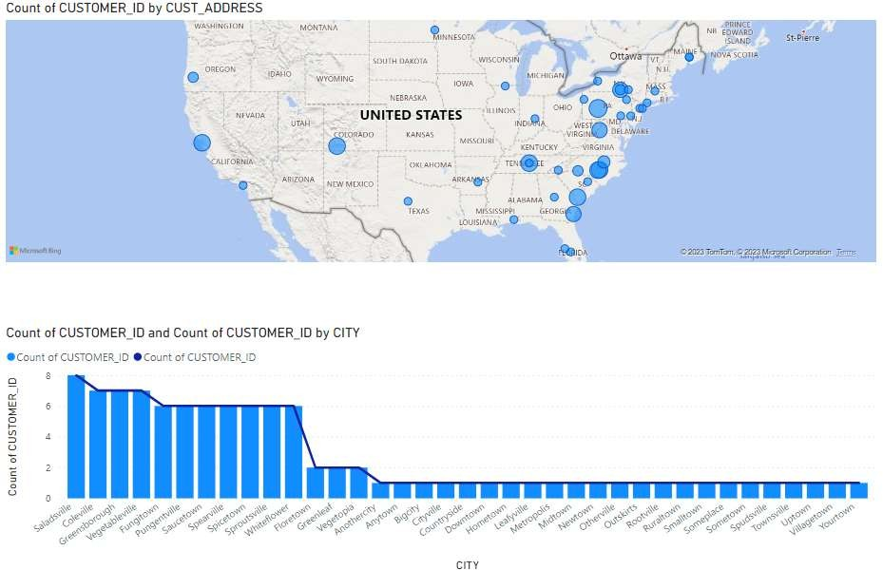

Total No of Customers (CITY & ADDRESS-WISE)

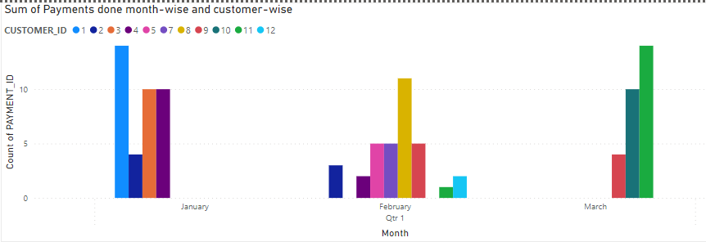

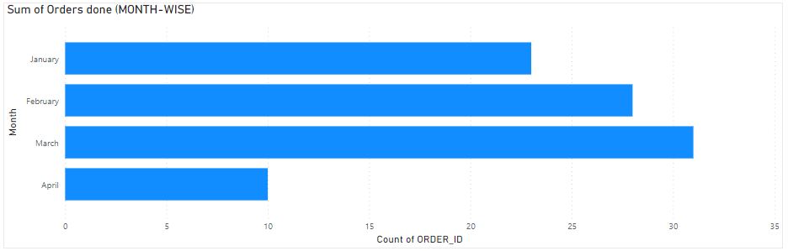Total Payments-Done (MONTH-WISE & CUSTOMER-WISE)

Total Orders Made (MONTH-WISE)

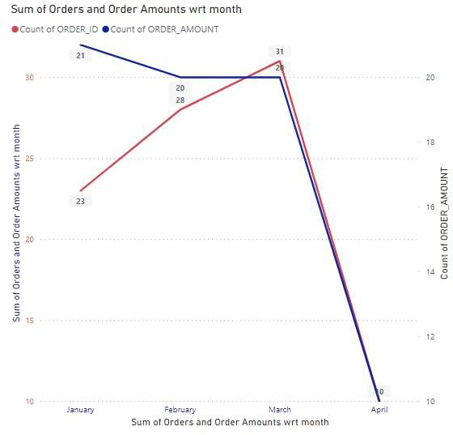 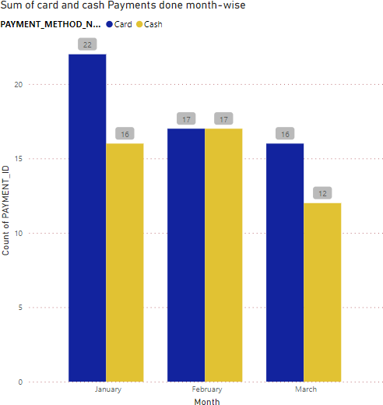

Sum of Orders & Order Amount (MONTH-WISE) Sum of Card & Cash Payments Made (MONTH-WISE)